Practical 6
A. prog to display Fibonacci series
Code –
# Python program to display the Fibonacci sequence

def recur_fibo(n):
if n <= 1:
return n
else:
return(recur_fibo(n-1) + recur_fibo(n-2))

nterms = 10

# check if the number of terms is valid
if nterms <= 0:
print("Plese enter a positive integer")
else:
print("Fibonacci sequence:")
for i in range(nterms):
print(recur_fibo(i))

Output –
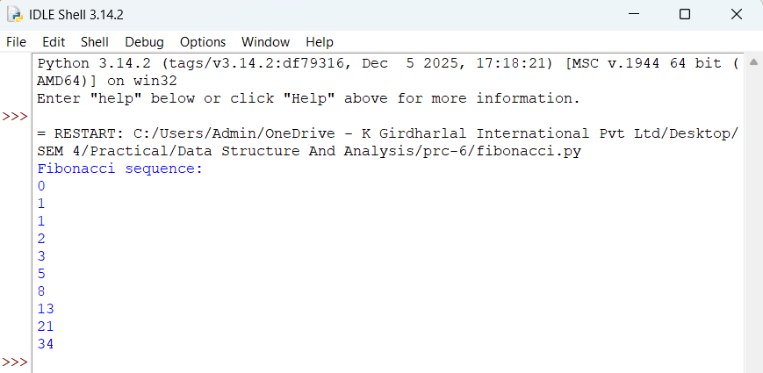

B. Prog to find to factorial of a no
Code –
# Factorial of a number using recursion

def recur_factorial(n):
if n == 1:
return n
else:
return n*recur_factorial(n-1)

num = 7

# check if the number is negative
if num < 0:
print("Sorry, factorial does not exist for negative numbers")
elif num == 0:
print("The factorial of 0 is 1")
else:
print("The factorial of", num, "is", recur_factorial(num))

Output –
